Homework #10

Math 131-05D-spring 2017

5/5/17 at 12:00 PM

By Yeash Patel

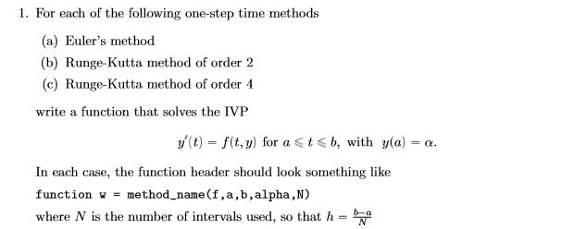

One can see the functions in appendix A. To show how to use the these functions we will be solving for y`=y which we know that y=exp(t) which shall solve from interval 0 to 2 for 100 iterations. The functions should return a numerical value close to 7.38905609893

**MATLAB Input and Output**

>> f= @(t,y)y

f =

function_handle with value:

@(t,y)y

>> Euler(f,0,2,1,100)

ans =

7.2446

>> RK2(f,0,2,1,100)

ans =

7.3881

>> RK4(f,0,2,1,100)

ans =

7.3891

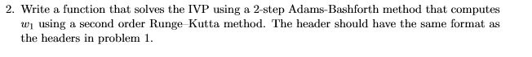

One can also see the functions in appendix A. To show how to use the functions we will be solving for y`=y which we know that y=exp(t) which shall solve from interval 0 to 2 for 100 iterations. The functions should return a numerical value close to 7.38905609893

**MATLAB Input and Output**

>> f=@(t,y) y

f =

function_handle with value:

@(t,y)y

>> AB2(f,0,2,1,100)

ans =

7.3866

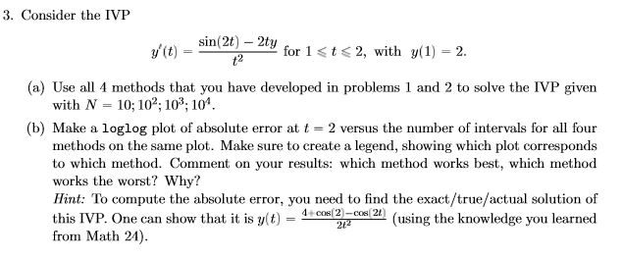

I wrote script to simplify the commands needed to evaluate this problem. As seen in the graph the Runge-Kutta 4 method preformed the best out the four however it should be noted that the method requires a lot of function evaluations. The worst performer according the graph was by the Euler method. The Euler method did not perform as well, but has a lower function evaluation requirement and therefore requires less resources.

**MALAB Input**

>> Pr3

**MATLAB Output**

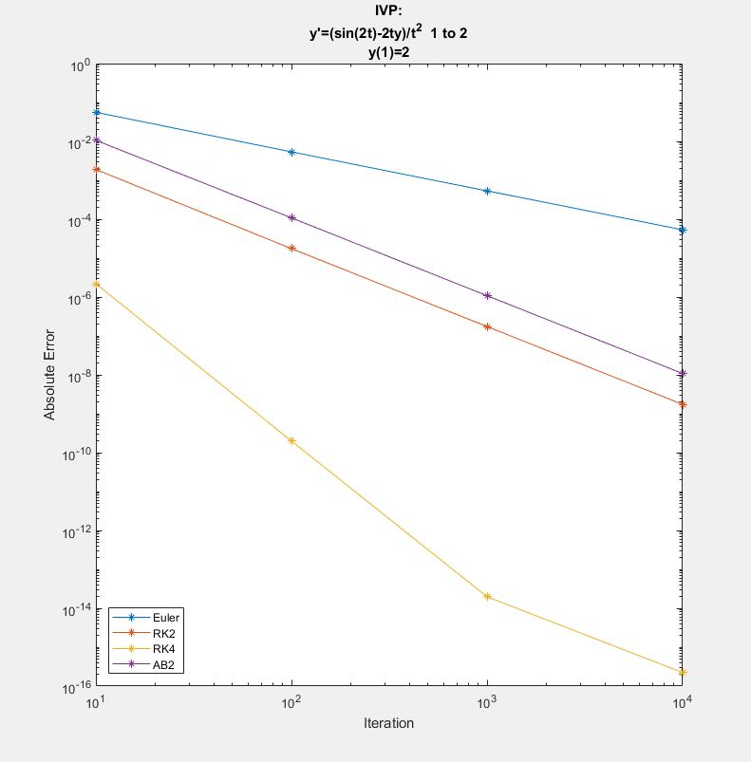

APENDIX A

**Euler.m**

function [w] = Euler( f,a,b,alpha,N )

h = (b-a)/N;

t=a;

w=alpha;

for i=(1:N)

w=w+h*f(t,w);

t=a+i*h;

end

end

**RK2.m**

function [ w ] = RK2(f,a,b,alpha,N)

h = (b-a)/N;

t=a;

w=alpha;

for i=(1:N)

k1=f(t,w);

t=a+i*h;

k2=f(t,w+h*k1);

w=w+h/2*(k1+k2);

end

end

**RK4.m**

function [ w ] = RK4(f,a,b,alpha,N)

h = (b-a)/N;

t=a;

w=alpha;

for i=(1:N);

k1=h*f(t,w);

k2=h*f(t+h/2,w+k1/2);

k3=h*f(t+h/2,w+k2/2);

k4=h*f(t+h,w+k3);

w= w+1/6*(k1+2*k2+2*k3+k4);

t=a+i*h;

end

end

**AB2.m**

function [ Z ] = AB2( f,a,b,alpha,N )

h = (b-a)/N;

t(1)=a;

w(1)=alpha;

k1=f(t(1),w(1));

t(2)=a+h;

k2=f(t(2),w(1)+h*k1);

w(2)=w(1)+h./2*(k1+k2);

for i=(2:N)

w(i+1)=w(i)+h/2*(3*f(t(i),w(i))-f(t(i-1),(w(i-1))));

t(i+1)=a+i*h;

Z=w(i+1);

end

end

**Pr3.m**

clc

clear all

close all

f = @(t,y) (sin(2*t)-2*t*y)./t.^2;

a=1;

b=2;

alpha=2;

t=2;

y=(4+cos(2)-cos(2*t))./(2*t.^2);

for i=(1:4)

N=10^i;

xx(i)=N;

Euz(i)= Euler(f,a,b,alpha,N);

errEuz(i)=abs(Euz(i)-y);

RK2z(i)= RK2(f,a,b,alpha,N);

errRK2z(i)=abs(RK2z(i)-y);

RK4z(i) = RK4(f,a,b,alpha,N);

errRK4z(i)=abs(RK4z(i)-y);

AB2z(i) = AB2(f,a,b,alpha,N);

errAB2z(i)=abs(AB2z(i)-y);

end

loglog(xx,errEuz,'-*',xx,errRK2z,'-*',xx,errRK4z,'-*',xx,errAB2z,'-*')

legend('Euler','RK2','RK4','AB2','Location', 'Southwest')

title({'IVP:','y''=(sin(2t)-2ty)/t^2 1 to 2','y(1)=2'})

xlabel('Iteration')

ylabel('Absolute Error')